

**Joseph Banks  
Secondary College**

**Research Methods, Relational Influences and Cognition   
Worth 8% of the School Mark**

**Question/Answer Booklet**

**PSYCHOLOGY**

**Unit 3**

Student name : __________________________________________

# Time allowed for this paper

## Reading time before commencing work**: five minutes**

Working time for the paper: **fifty minutes**

# Materials required/recommended for this paper

***To be provided by the supervisor:***

This Question/Answer Booklet

Formulae and Data Booklet

***To be provided by the candidate:***

Standard items: pens (blue/black preferred), pencils (including coloured), sharpener,

correction tape/fluid, eraser, ruler, highlighters.

Special items: non-programmable calculators approved for use in the WACE examinations

# Important note to candidates

No other items may be taken into the examination room. It is **your** responsibility to ensure that you do not have any unauthorised notes or other items of a non-personal nature in the examination room. If you have any unauthorised material with you, hand it to the supervisor **before** reading any further.

**Structure of this paper**

|  |  |  |  |  |  |
| --- | --- | --- | --- | --- | --- |
| Section | Number of questions available | Suggested working time  (minutes) | Your Mark | Marks available | Percentage of test |
| Section One:  Research Methods | 3 | 20 |  | 17 | 50 |
| Section Two:  Short Answer | 2 | 27 |  | 28 | 50 |
|  |  | **Total** |  | 45 | 100 |

**Instructions to candidates**

1. The rules for the conduct of Western Australian external examinations are detailed in the *Year 12 Information Handbook 2016*. Sitting this examination implies that you agree to abide by these rules.
2. Write your answers in this Question/Answer Booklet.
3. When calculating numerical answers, show your working or reasoning clearly. Your working should be in sufficient detail to allow your answers to be checked readily and for marks to be awarded for reasoning.

In calculations, give final answers to one significant figures and include appropriate units where applicable.

1. You must be careful to confine your responses to the specific questions asked and to follow any instructions that are specific to a particular question.
2. Supplementary pages for the use of planning/continuing your answer to a question may have been provided at the end of this Question/Answer booklet. If you use these pages to continue an answer, indicate at the original answer where the answer is continued, i.e. give the page number.

**Section One – Research Methods (17 marks)**

**Section One – Research Methods**

**Question One (6 marks)**

Dr Chaz is planning an experiment to determine the effect of a study strategy called ‘mind mapping’ on student test scores at Marina Senior College. He used 100, 17-year-old Year 11 Psychology students, 50 of which he taught to use the mind mapping strategy and 50 which he did not.

1. Write an operational hypothesis for this experiment. (3 marks)

|  |  |
| --- | --- |
| **Description** | **Mark** |
| Must include:  Population  Measurable IV / DV  Compared to a control group  *Must be written in a predictive format*  e.g.  **It is hypothesised that 50 Year 11 Psychology students who utilise the mind mapping strategy, will achieve higher test scores, than 50 Year 11 Psychology students who do not utilise the strategy and complete the same assessments.** | 1  1  1 |

1. State the population from which the sample was drawn.

|  |  |
| --- | --- |
| **Description** | **Mark** |
| **Year 11 Psychology students** | 1 |

1. State the independent variable:

|  |  |
| --- | --- |
| **Description** | **Mark** |
| **Mind mapping or no mind mapping** | 1 |

1. State the dependent variable:

|  |  |
| --- | --- |
| **Description** | **Mark** |
| **Test scores** | 1 |

**Question Two (3 marks)**

Cognitive test scores for a group of students are listed below.

2, 1, 7, 9, 5, 5, 4, 11

Calculate the following:

|  |  |
| --- | --- |
| **Description** | **Mark** |
| **Mean 5.5**  **Median: 5** |  |

b) Explain which measure of central tendancy is impacted by outliers in the data.

|  |  |
| --- | --- |
| **Description** | **Mark** |
| **Mean** | 1 |

**Question Three (8 marks)**

A psychologist wanted to investigate the relationship between temperature and performance on a test of memory. The psychologist required a sample of 60 adults to participate, firstly in a room where the temperature was 16 °C; and secondly in a room where the temperature was 44 °C.

1. Outline **three** ethical considerations the psychologist must adhere to and **how** they can achieve this. (6 marks)

|  |  |
| --- | --- |
| **Description** | **Mark** |
| 1. For identifying the participant right (1) for describing HOW the researcher can follow this   Informed consent: Will need to inform subjects that may be put in a room that is very hot or quite cold, outline the purpose and sign a consent form  right to withdraw: at any stage without penalty  Confidentiality: no personal information will be given out a code instead of name  OR ANYOTHER REASONABLE RESPONSE |  |

1. Identify whether this is an experimental or non-experimental study and give a reason for your answer.

|  |  |
| --- | --- |
| **Description** | **Mark** |
| Experimental (1) manipulating variables to see cause & effect; there is an IV and DV.(1) |  |

1. Identify whether this research was scientific or non-scientific, justify your answer.

|  |  |
| --- | --- |
| **Description** | **Mark** |
| Scientific (1) as it follows a structured method (1) or the concept is testable and measurable (1) |  |

**Section Two- Short Answer Questions (15 marks)**

1. Define the term communication styles. Give two examples. (2 marks)

|  |  |
| --- | --- |
| **Description** | **Mark** |
| Scientific (1) as it follows a structured method (1) or the concept is testable and measurable (1) |  |

1. Describe the elaborative language code. (2 marks)

|  |  |
| --- | --- |
| **Description** | **Mark** |
| Scientific (1) as it follows a structured method (1) or the concept is testable and measurable (1) |  |

1. Describe the restricted language code . (2 marks)

|  |  |
| --- | --- |
| **Description** | **Mark** |
| Scientific (1) as it follows a structured method (1) or the concept is testable and measurable (1) |  |

1. Compare Labov and Bernstein’s theories of communication style (4 marks)

|  |  |
| --- | --- |
| **Similarities** | **Differences** |
| Both investigated the social and cultural aspects of communication styles (1)  Both agreed there are differences in different social groups and how they communication (1) | Bernstein believed there was a deficit in the language used by the working class (1)  Labov did not see one as superior / inferior (1)  *Accept any other relevant correct answer* |

1. *“Women create feelings of closeness by conversing with their friends and lovers. Men don’t use communication in this way, so they can’t figure out why their women are continually talk, talk, talking. Eventually, many men just tune their women out”*

- Laura Morrison commenting on Deborah Tannen’s book *You Just Don’t Understand*

Explain how men and women use communication for different purposes. Include in your answer how this can lead to misunderstanding and even conflict in a relationship. (*5 marks*)

|  |  |
| --- | --- |
| **Description** | **Mark** |
| Men use report talk (1) and communicate for status and solutions(1), whereas women use rapport talk (1) and communicate to build connection and discussion between people(1) This can led to conflict as both parties do not understand the underlying needs of the other party (1) |  |

**Question 2 – Persuasive communication (13 marks)**

1. Compare the central and peripheral routes of persuasion. (4 marks)

|  |  |  |
| --- | --- | --- |
|  | **Role of the audience** | **Content of message** |
| **Central** | Active | Thought provoking |
| **Peripheral** | Passive | Uses social cues to persuade the audience rather than the direct message itself |

1. Analysing the image below, identify and explain how one feature of persuasive communication has been used to make the advert persuasive. (3 marks)

|  |  |
| --- | --- |
| **Description** | **Marks** |
| Identifies a feature (1)  e.g.  *Characteristics of the audience*  Describes what they see (1)  *A health conscious and active man rock climbing, casualing drinking the product while holding onto the rock*  Applies how it makes it persuasive (1)  *This advert would be persuasive to the audience as it is a product targeting at health-conscious men, using a ripped man to advertise a muscle building” protein shake* |  |

c) Analysing the image below, identify and explain how one feature of persuasive communication has been used to make the advert persuasive. (3 marks)

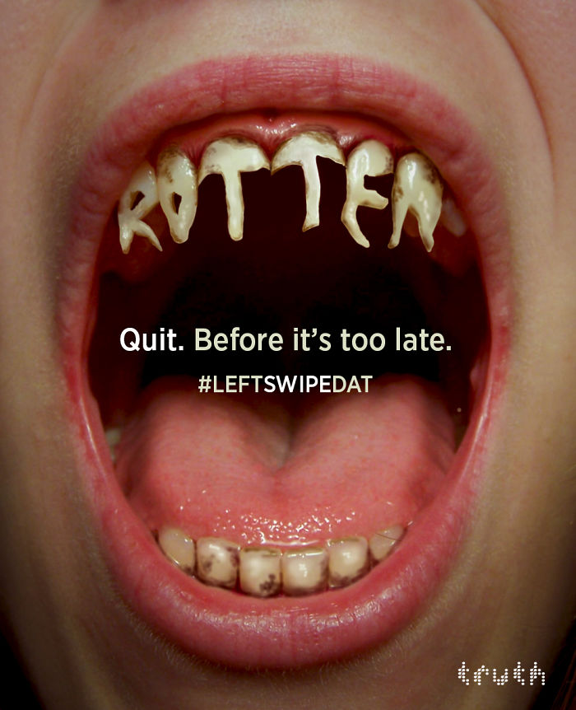

|  |  |
| --- | --- |
| **Description** | **Marks** |
| Identifies a feature (1)  e.g.  *Nature of the communication*  Describes what they see (1)  *The advert shows a person’s rotten teeth from smoking and is zoomed into show just the mouth*  Applies how it makes it persuasive (1)  *This advert is persuasive as it draws your attention quickly and evokes a quick emotion of disgust to try to prevent the audience from smoking* |  |

Analysing the image below, identify and explain how one feature of persuasive communication has been used to make the advert persuasive. (3 marks)

|  |  |
| --- | --- |
| **Description** | **Marks** |
| Identifies a feature (1)  e.g.  Source of the message  Describes what they see (1)  *The advert uses Usain Bolt who world’s fastest man and well-known Olympian for running, he has a Puma shoe hovering over his hand.*  Applies how it makes it persuasive (1)  *This advert is persuasive as it shows that the shoe is used by and endorsed by an expert in the field and a well-known and liked celebrity therefore people are more likely to tryst his endorsement* |  |

